Social Media

To increase your presence on social media and provide additional education to your patients, you can easily retweet and repost Metabolic Code updates to your social media accounts.

Metabolic Code on Twitter: https://twitter.com/MetabolicCode
Metabolic Code on Facebook: https://www.facebook.com/TheMetabolicCode/

Twitter:
Username: @MetabolicCode

- To retweet: Login into Twitter with the desired account to publish on. Next, go to the Metabolic Code Twitter account (link provided above). If you see a tweet, and you would like to retweet, simply click on the retweet button below the post, add any comments you would like to publish and click the blue retweet button.
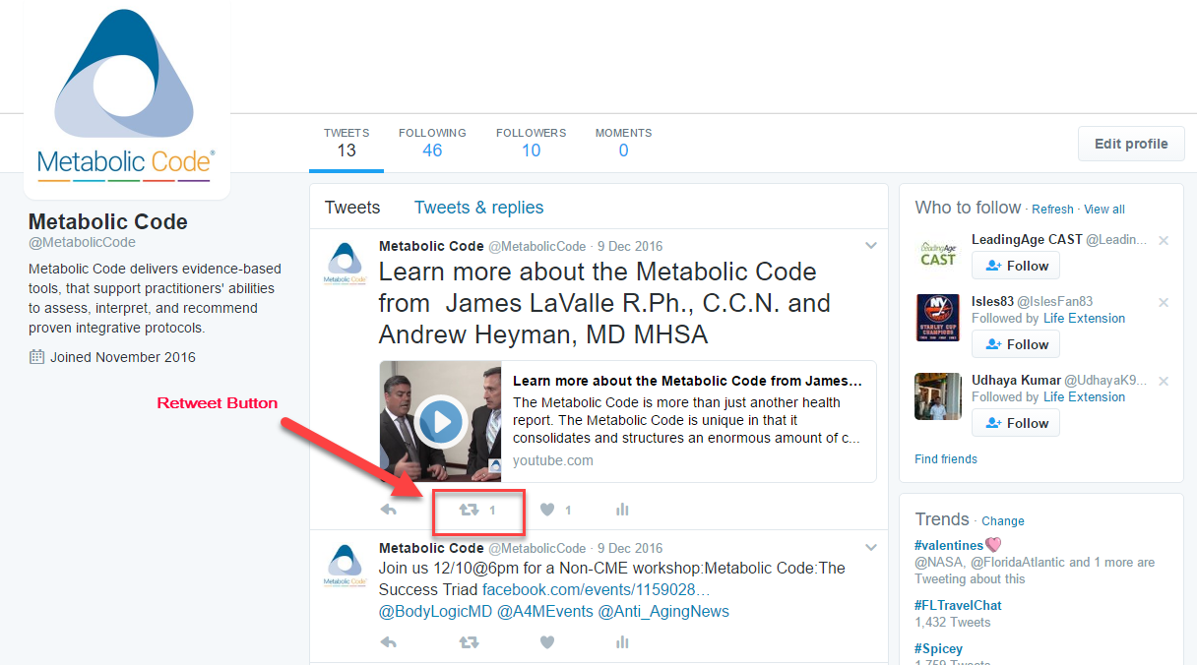

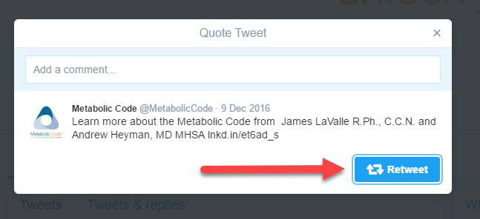

Facebook:
Username: @TheMetabolicCode

- To re-post: Login into Facebook with the desired account to publish on. Next, go to the Metabolic Code Facebook account (link provided above). If you see a post you would like to publish, just click on the ‘Share’ button below the post. You can select to ‘Share Now (Public),’ and it will automatically post to your page. You can also select ‘Share…’ which will allow you to add comments you would like to publish. When you are ready to share with your audience, click the blue ‘Post’ button.

